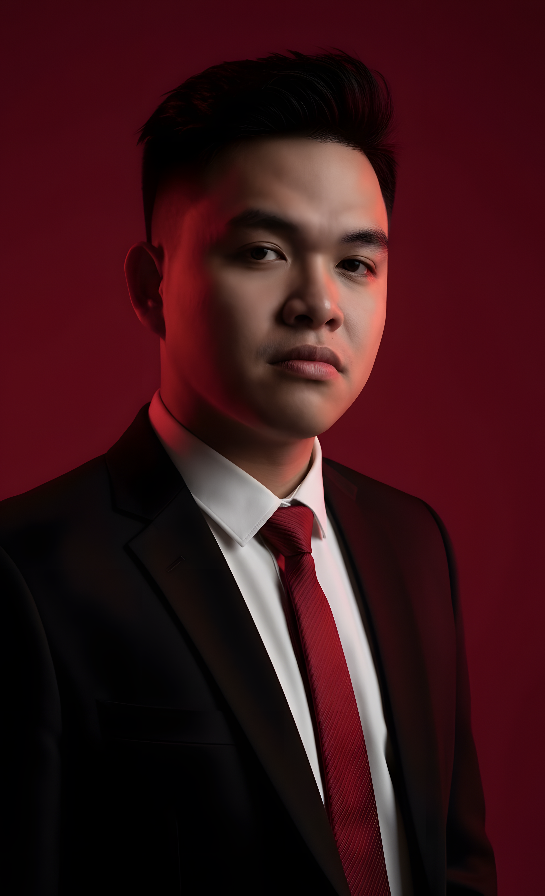
Johnie Niel D. Derubio

CONTACT  📞 09709286874  ✉ johniedy2003@gmail.com  📍 Brngy Labo, Ozamiz City, Mis Occ  🌐 https://github.com/Argykaka/Personalprofile  SKILLS  - UI Designer  - UX Designer  - Cement Mixer  - Prototyping  - Usability Testing  - Web Programming  EDUCATION  Northwestern Mindanao State College  Undergrad  2024 – Present  Misamis University  Senior High School  2020 – 2022  Brother Martin Simpson Laboratory School  Elementary  2010 – 2016 | SUMMARY  Creative and adaptable UI/UX Designer with experience in responsive web design, prototyping, and usability testing. Skilled in WordPress development and web programming, with a unique foundation in hands-on work that brings precision and reliability to every project.  WORKING EXPERIENCE  LABORER  Housing Project | 2016  • Cement prep  • Sand & rock segregation  • Painter  FREELANCE WEB DESIGNER  Client | 2022 – 2023  • Designed and developed custom WordPress websites for small businesses and startups.  • Delivered responsive layouts, UI mockups, and content updates tailored to each brand’s identity.

